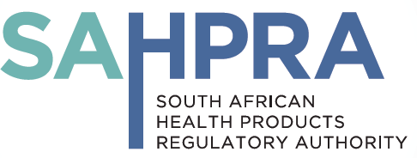

NOTIFICATION STUDIES: PHASE IV

This is intended for Applicants to notify the South African Health Products Regulatory Authority (SAHPRA) of intention to undertake a phase IV clinical study of an approved medication within its approved dosage, formulation and indication.

Instructions:
Complete all parts of this form.
Note that this form cannot be used for any investigational product that is not registered, nor for any medication used outside of its registered indication and dose or dosage form as per its (SAHPRA) approved professional information (package insert).
Attach the following:
- Cover letter
- Completed form
- SAHPRA approved professional information (package inserts) for medication being investigated
- Copy of application letter to Ethics Committee/ Ethics Committee approval
- Protocol
- Patient Information Leaflet/informed consent document (PIL/ICON)

Applicant Contact Details:

- Name(s) of ethics committee(s):

- Name of Principal Investigator(s) and site(s):

- Title of the study:

- Primary Objectives:

- Study medication information (name, dose and formulation):

 |  | Yes | No
7. | Is the medicine registered in SA for the study population?
8. | Is the medication being used for its registered indication?
9. | Is the medication being used at a dose and formulation that it is registered for?
10. | Is the medication being sourced in South Africa?

Please note that if the answer to any of questions 7, 8, 9, or 10 above is "No", then a full Clinical Trials Form (CTF1) must be completed.
NB: For observational studies/non-interventional studies, applicants should submit to Ethics Committees only for authorisation.

Applicant Signature

Received by (SAHPRA) [For office use]

UPDATE HISTORY

Date | Reason for update | Version & publication
April 2017 | First version approved for implementation | v 1, May 2015
May 2019 | Administrative Changes | v 2, May 2019

