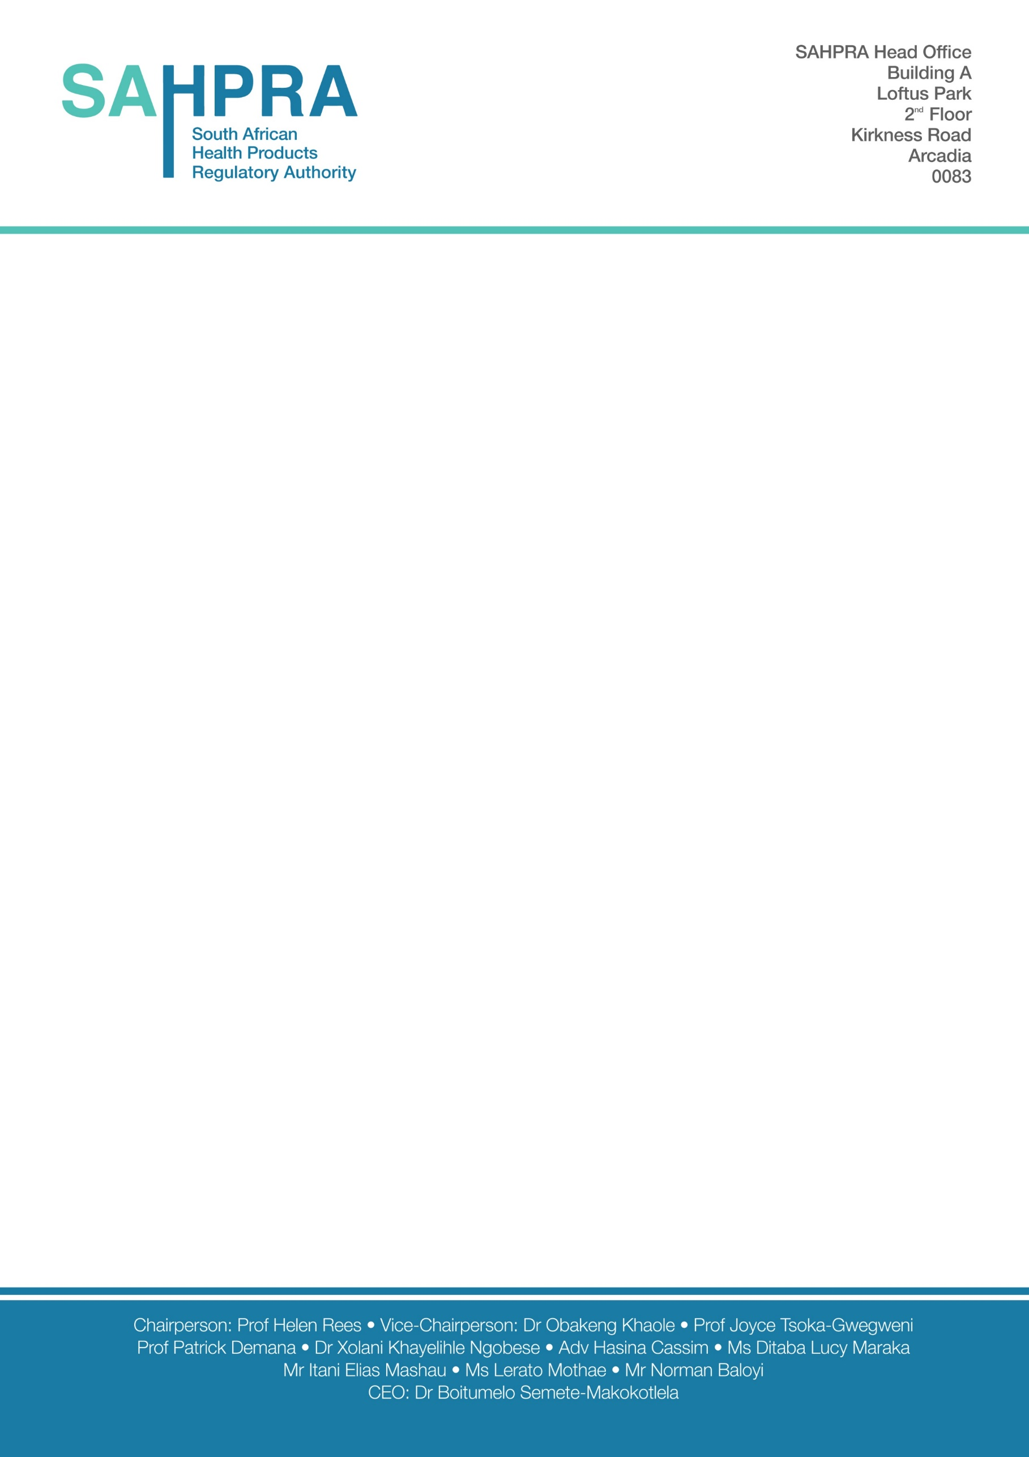

|  |
| --- |
| **NOTIFICATION OF NITROSAMINE RISK EVALUATION OUTCOME: RISK/NO RISK IDENTIFIED[1]** |

From Holder of Certificate of Registration (HCR) on the Company Letterhead

*Reference*: VRR (Nitrosamines) Company name

*HCR Address:*

*Date*: DD/MM/YYYY

**RE: Risk evaluation outcome: confirmation of risk of nitrosamine presence identified**

Dear PEM Pre-registration Unit Manager

I herewith confirm that having performed the requested risk assessment evaluation, applying principles outlined in the communique “communication to industry on nitrosamine review for new applications and registered products including biologicals”, the risk of presence of nitrosamines **was/ was not** (underline the relevant option) identified in the following Active Pharmaceutical Ingredient (API) and Final Pharmaceutical Product (FPP):

|  |  |
| --- | --- |
| Registration number(s) |  |
| Proprietary name(s) (including duplicates) |  |
| Dosage Form and Strength |  |
| API(s) |  |

Confirmatory testing is planned to start on << insert timeline for confirmatory testing>> and is expected to be completed by <<insert timeline for completing confirmatory testing>>. An update will be provided by <<insert timeline for update>>

I herewith confirm that the review performed was adequately documented and risk assessment documentation can be made available upon request.

Yours sincerely,

Signature of person authorised to communicate with SAHPRA

<<HCR>>

1. Report format adapted from EMA template for the notification of step 1 risk evaluation outcome: risk identified <https://www.ema.europa.eu/en/human-regulatory/post-authorisation/referral-procedures/nitrosamine-impurities>